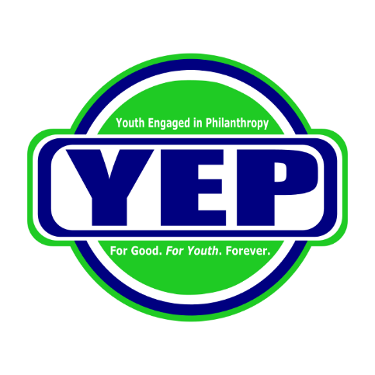

2022 Youth Engaged in Philanthropy Follow-Up Report

As stated in the requirements of your grant agreement, the follow-up report of your organization’s grant activity must be submitted. We appreciate the time and effort you will invest in its preparation, and we look forward to reviewing it. In order to do so, please answer the following questions completely and thoroughly. Please type your answers in a separate document and number your answers according to the corresponding questions. Please send the report and this cover sheet, complete with signature, to Illinois Prairie Community Foundation: 915 E Washington St, Suite 2, Bloomington, IL 61701. If you prefer, you may email the report as an attachment to Michele Evans at mevans@ilprairiecf.org. The due date for your follow-up report may be found in your grant agreement.

Questions to address in the report:

- Describe your project including the parts that did and did not go according to plan.
- What goals and objectives were met or were not met?
- What challenges or opportunities arose?
- Is your organization planning on doing the project again?
- If so, what parts would change or would stay?
- How were youth affected? (Testimonials work great)
- How many people were involved in your project as staff, volunteers, youth, etc.?
- How were the allocated funds used? (Please attach an updated and accurate budget)
- Were any of the allocated funds not used?
- How was YEP acknowledged? (Please include links or paper copies)
- What publicity did your project receive? (Please attach any articles, photographs, etc.)

We hereby confirm that this grant was used only for charitable purposes and that the answers provided in this YEP Grant Follow-Up Report are accurate to the best of our knowledge.

CEO/Executive Director: ________________________________________ Date: _________________

Report prepared by, and Title: ___________________________________ Date: _________________

Phone: ____________________________ Email: ___________________________________________

