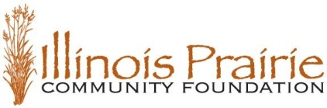
2018 Philanthropist of the Year Nomination Form

Submit form to lshepherd@ilprairiecf.org or mail to:
Illinois Prairie Community Foundation,
2401 E Washington St, Suite 300B, Bloomington, IL 61704

Deadline for submission is 4:30 p.m. on July 31, 2018

Criteria for nomination – an individual, couple or family residing in McLean, DeWitt, Livingston or Logan County who demonstrates:
- Outstanding civic responsibility through contributions of financial resources and voluntary commitment of time.
- Willingness to serve in leadership roles, providing vision and the ability to involve others in philanthropic activity.
- Impact of philanthropic efforts.

A relationship with the Community Foundation is desirable but not required. Current IPCF Board members and staff are not eligible for nomination.

Top two nominees not selected in previous year will automatically be considered for current year.

Past Recipients of the Illinois Prairie Community Foundation’s
Philanthropist of the Year Recognition:

George and Myra Gordon - 2017
Darrell and Donna Hartweg - 2016
John and Marilyn Freese - 2015
John and Jan Wohlwend - 2014
Bob and Julie Dobski -2013
Roger and Mary Hunt – 2012
(Celebration was not held in 2011)
Deanna Frautschi and Alan Bedell - 2010
Jerry and Carole Ringer – 2009

2018 Philanthropist of the Year Nomination Form
Information about Philanthropist(s) of the Year Nominee(s):
Name(s)

Address

Daytime Phone

Email

In 250 words or less, tell us why you believe the individual(s) listed above should be named
Illinois Prairie Community Foundation’s 2018 Philanthropist(s) of the Year.

Nominator Information:

Name(s)

Address

Daytime Phone

Email

